
Symbiosis Institute of Technology, Pune
Faculty of Engineering
CSE- Academic Year 2026-27
Java Programming – Lab Batch 2024-28
Lab Assignment No:- 19
Name of Student | Aarushi Raizada
PRN No. | 25070122002
Batch | 2025-29
Class | A1
Academic Year & Semester | 2026 SEM III
Date of Submission | 28th August, 2026
Title of Assignment: | Develop a Java application to establish connectivity with a database and perform data retrieval using the SELECT operation.
Theory  Practice questions | Java Database Connectivity (JDBC) is a standard Java API that enables communication between Java applications and relational databases. It provides a platform-independent mechanism to connect to databases such as MySQL, Oracle, PostgreSQL, and SQL Server. Before executing SQL statements, a JDBC driver is loaded and a connection is established using the DriverManager class. The Connection object represents an active connection to the database, while the Statement object is used to execute SQL queries. The SELECT statement retrieves records from database tables based on specified conditions. The retrieved records are stored in a ResultSet object, which allows sequential access to the data. JDBC simplifies database programming and is widely used in desktop, web, and enterprise applications.  1. Create a Java application to display student records from database using SELECT query  // Source code is decompiled from a .class file using FernFlower decompiler (from Intellij IDEA).  import java.sql.Connection;  import java.sql.DriverManager;  import java.sql.ResultSet;  import java.sql.Statement;  public class CreateDB {  public CreateDB() {  }  public static void main(String[] args) {  String url = "jdbc:mysql://localhost:3306/studentdb";  String user = "root";  String password = "Aarushi@7002";  try {  Class.forName("com.mysql.cj.jdbc.Driver");  Connection con = DriverManager.getConnection(url, user, password);  System.out.println("Connected to MySQL Database!");  Statement stmt = con.createStatement();  ResultSet rs = stmt.executeQuery("SELECT * FROM student");  while(rs.next()) {  int id = rs.getInt("id");  String name = rs.getString("name");  int marks = rs.getInt("marks");  System.out.println(id + " " + name + " " + marks);  }  con.close();  } catch (Exception e) {  System.out.println(e);  }  }  }  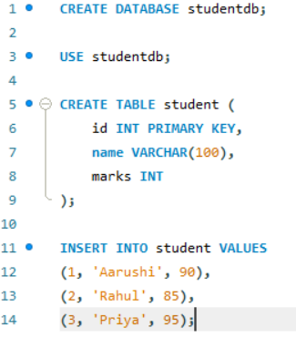  2. Create a Java application that connects to a database and displays product detailsusing a SELECT query. Show product ID, product name, quantity, and price.  import java.sql.*;  public class Main {  public static void main(String[] args) {  String url = "jdbc:mysql://localhost:3306/studentdb";  String user = "root";  String password = "root";  try {  Class.forName("com.mysql.cj.jdbc.Driver");  Connection con = DriverManager.getConnection(url, user, password);  Statement stmt = con.createStatement();  ResultSet rs = stmt.executeQuery("SELECT * FROM product");  while (rs.next()) {  System.out.println("ID: " + rs.getInt("id"));  System.out.println("Name: " + rs.getString("name"));  System.out.println("Quantity: " + rs.getInt("quantity"));  System.out.println("Price: " + rs.getDouble("price"));  System.out.println();  }  con.close();  } catch (Exception e) {  System.out.println(e);  }  }  }  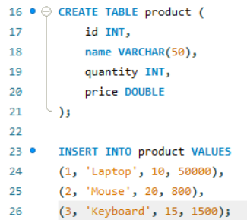
Output Screenshots (if applicable) | Ans 1  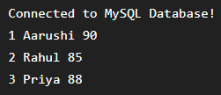  Ans 2  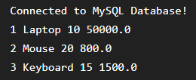
Conclusion | In this experiment, we learnt to establish database connectivity and retrieve records using JDBC SELECT statements.

